Solution of Theory part

Q1
- The median is the value such that half of the values lie on either side of it.
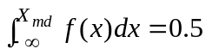 X continuous
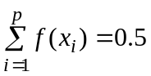 X discrete

The mode is the value x having largest associated probability.
For discrete variable the mode is the value of x which appear more times than any others or associated with
max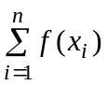

For a continuous variable the mode is the value of x satisfying
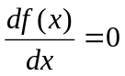 and 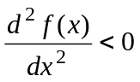

- Example: 1, 2, 3, 4, 5. Its mean = 3 = median
- Example: 1, 2, 3, 3, 4, 5. Its mode = 3 = median

Solution of Q2.
- A is negative Binomial distribution, B is geometric distribution
- For A: x is number of trials, k is number of success, p is probability of one success, and q is probability of failure.
For equation (B): x is number of trials, p is probability of one success, and q is probability of failure.
- What is the probability that the fourth occurrence of a 10-year flood will be on the fortieth year?
In this example: k=4, x=40, p=0.1, q=0.9
- What is the probability that a 10 year flood will occur first time in the 10th year??
In this example, p = 0.1, q = 0.9, x = 10
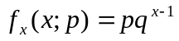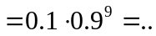

Q3

(A)

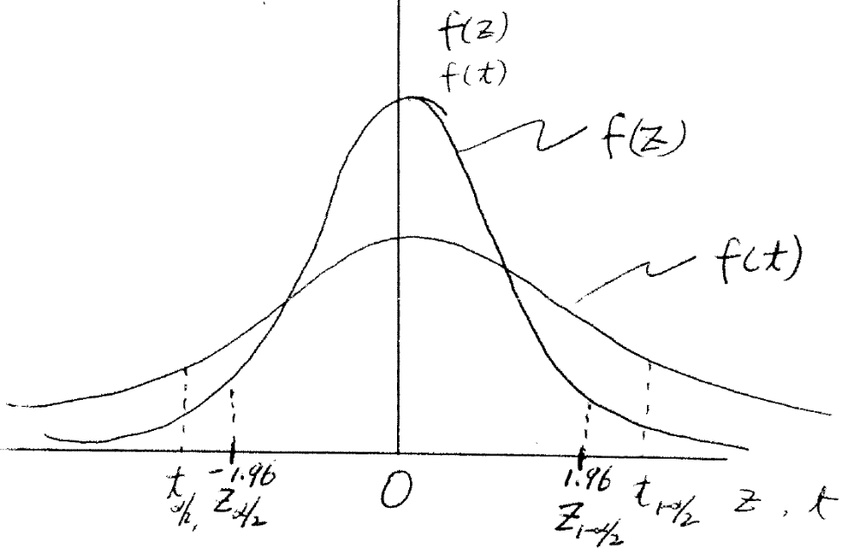
(B) The areas under the density curves of f(z) and f(t) with boundaries of Z_{0.025} – Z_{0.972} and t_{0.025} – t_{0.972} as indicated in the above figure are both equal to 95%. Because the density curve of t distribution with small freedom is more spread out compared with density curve of Z distribution, therefore, the boundaries for 95% area (probability) are wider than that of Z distribution.

Q4 About time series analysis and stochastic modeling
Answer the following statements with “True” if it is always true, otherwise with “false”
(i) (ii) (iii) (iv) (v) (vi) (vii) (viii) (ix) (x)
T F F T F F F F F F

Calculus part

Q2
a) 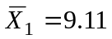 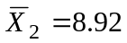
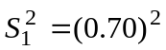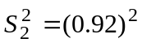
Ho: 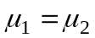 Ha: 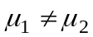

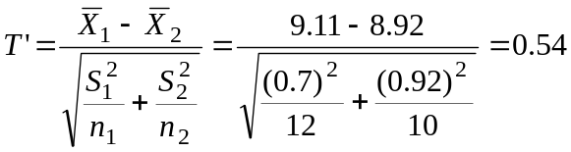

Ho rejects if T’ > (w₁t₁+w₂t₂)/(w₁+w₂)

Where 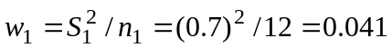
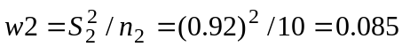
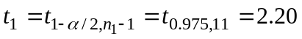
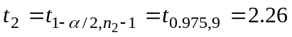
and 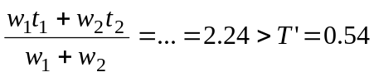

Therefore the hypothesis of the means are not affected cannot be rejected.

b) Fc = 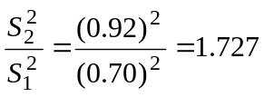
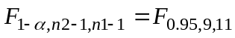≧2.8 (from F distribution table)
Since Fc <

Therefore the hypothesis of the variances are not affected cannot be rejected.

Q3
Let Y=lnQ, then 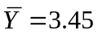 and S_{Y} = 0.36

- prob(Q>31.5) = prob (Y>ln(31.5)) = prob(Y>3.45) = prob (Z>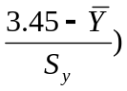
= prob (Z>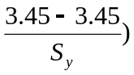= prob (Z>0.0)=1- prob(Z<0.0)
= 1-0.5 = 0.5

b) prob(Q<Q_{T})= 0.9 =prob(Y<Y_{T}) = 0.9 = prob(Z<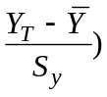
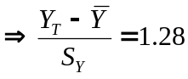  Y_{T} = 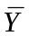+0.36*1.28=3.91
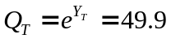
Answer: the magnitude of discharge is 49.9 m3/s

- Prob (15.55<Q<63.79) = prob (2.744 < Y < 4.156) =
Prob 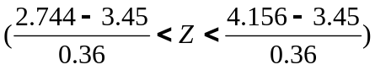=

Prob(-1.96<Z<1.96) = 0.95

d) prob(Q>Q_{T} in one year) = p
prob(Q<Q_{T} in one year) = 1-p
prob(Q<Q_{T} in 20 years) = (1-p)²⁰
(1-p)²⁰ = 0.1
p = 0.1087
prob(Q<Q_{T})=1-p = 0.891
prob(Y<Y_{T}) = 0.891=prob(Z<K_{T})
K_{T} = 1.23 (from table)
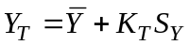=3.45+1.23*0.36=3.89
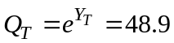 m3/s
Answer: the magnitude of the flow is 48.9 m3/s

e) prob(Q>50 in one year)=p
prob(Q<50 in one year)=1-p
prob(Q<50 in 3 year)=(1-p)³
prob(Q>50 at least once in 3 years)=1-(1-p)³

prob(Q>50) = prob (Y>ln(50)) = prob(Y>3.91) = prob (Z>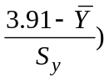
= prob (Z>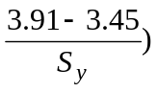= prob (Z>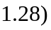=1- prob(Z<1.28)
= 1-0.8991 = 0.10
therefore 1-(1-p)³ = 1-(1-0.1)³ = 0.271

Answer: the probability is 0.271.

Q4
(A)
Q≤50 | 50<Q≤100 | 100<Q≤150 | 150<Q≤250 | Q>250
6 | 24 | 35 | 15 | 10 | Oj
5 | 25 | 20 | 26 | 14 | Ej | 90
1 | -1 | 15 | -11 | -4 | (Qj-Ej)
1 | 1 | 225 | 121 | 16 | (Oj-Ej)^2 | 364
0.2 | 0.04 | 11.25 | 4.653846 | 1.142857 | (Oj-Ej)^2/Ej | Χ²_{c}=17.2867
Χ²_{0.05,5-1} =9.488 < Χ²_{c}=17.28
Decision: the hypothesis of A and B belonging to same distribution is rejected.

(B)
Q≤50 | 50<Q≤100 | 100<Q≤150 | 150<Q≤250 | Q>250
6 | 24 | 35 | 15 | 10 |  | Oj
0.0548 | 0.2195 | 0.3881 | 0.3364 | 0.0082 | 1.007 | Expected rel freq
4.932 | 19.755 | 34.929 | 30.276 | 0.738 |  | Ej
0.23127 | 0.912175 | 0.000144 | 7.707629 | 116.2394 | (Oj-Ej)^2/Ej | Χ²_{c} =125.0906
P(Q<50) = p(z<(50-130)/50)=p(z<-1.6) = 1-0.9452=0.0548
p(Q<100) = p(z<(100-130)/50=p(z<-0.6)=1-0.7257=0.2743
p(50<Q<100)=0.2743-0.0548 = 0.2195
p(Q<150) = p(z<(150-130)/50=p(z<0.4)=0.6554
p(100<Q<150) = 0.6554-0.2743 = 0.3811
p(Q<250) = p(z<(250-130)/50)=p(z<2.4)=0.9918
p(150<Q<250) = 0.9918-0.6554 = 0.3364
p(Q>250) =1-P(Q<250) = 1-0.9918=0.0082

Χ²_{0.05,5-2-1} =5.991 < Χ²_{c}=125.09

Decision: The hypothesis of A is normally distributed is rejected.

